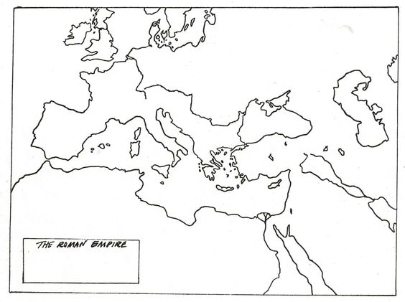
- Name ___________________________________Pd _______Date _______________________
- Map Exercise: Byzantine Empire & Medieval Europe

- Directions: Using maps on your phone with a partner complete the following

1. Draw and label a compass with the four cardinal directions.

2. Label the following bodies of water:
- Red Sea
- Atlantic Ocean
- Black Sea
- Mediterranean Sea
3. Outline and color the following empires:
- Byzantine Empire C. 527AD Before Justinian
- Islamic Empire 661 AD
- Holy Roman Empire (also called “Charlemagne’s Empire”)
- Justinians Empire C. 555 AD
6. Create a key indicating which color represents which empire.
7. Locate and label the following cities:
- Constantinople (Istanbul)
- Rome

8. Title your map at the top.

