County Choropleth Map
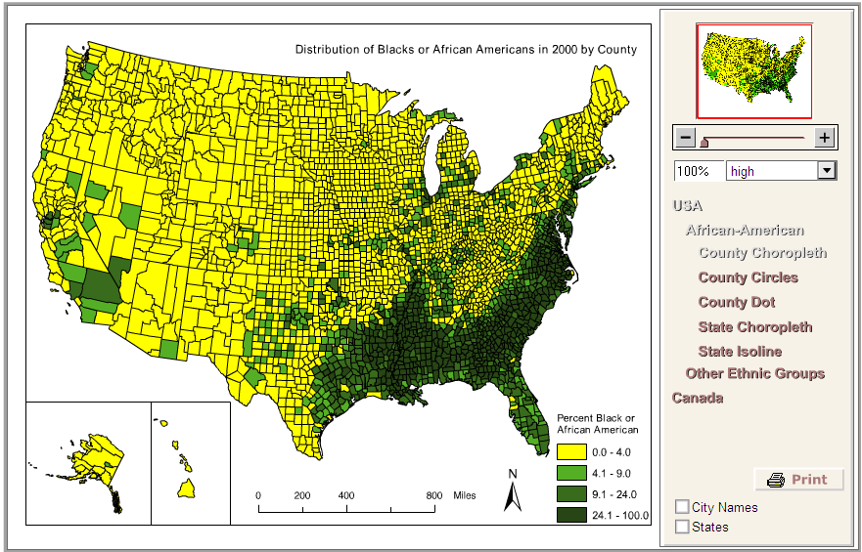

County Circles Map
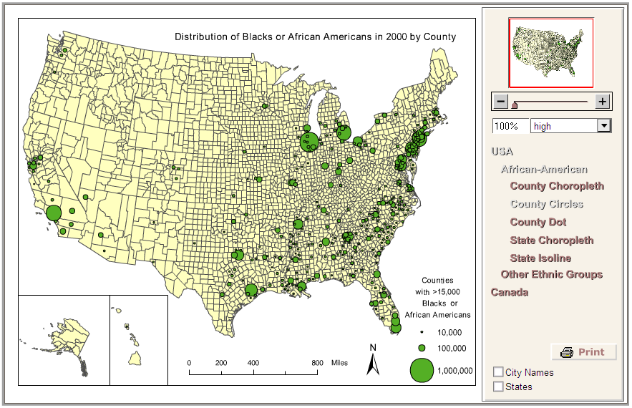

County Circles w/ labels
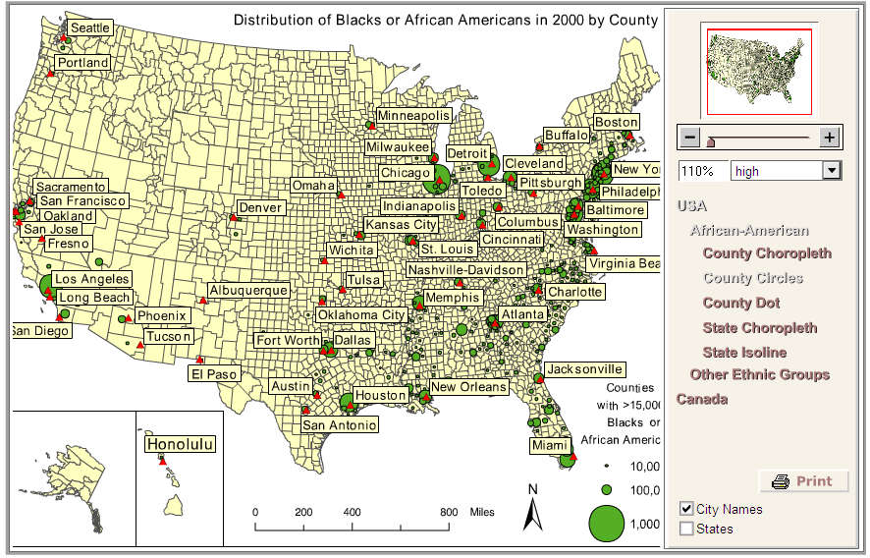

New York City- County Circles Map
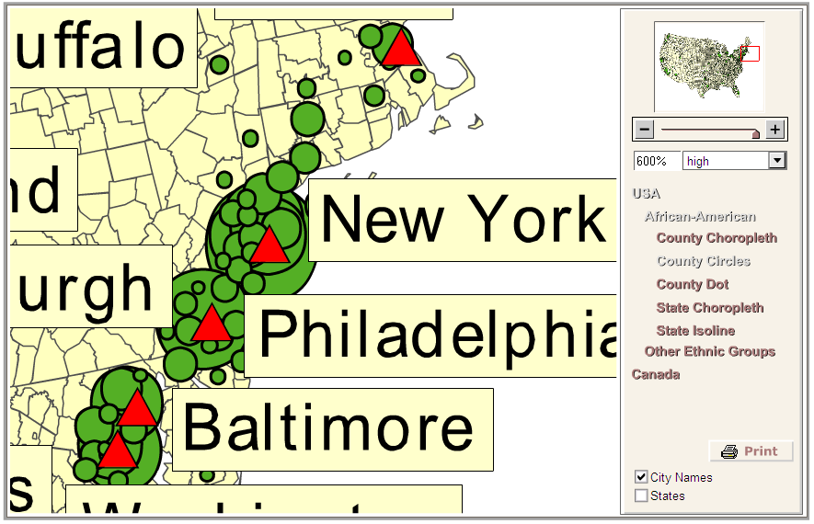

Dot Map- 5,000
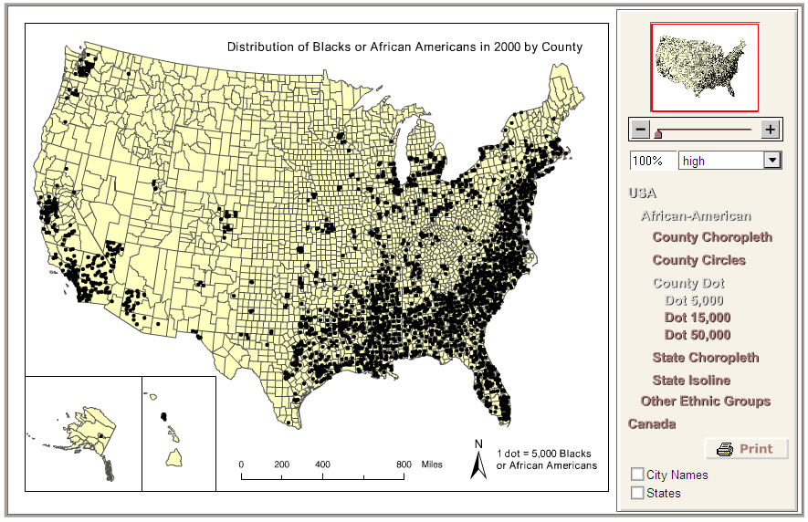

Dot Map- 15,000
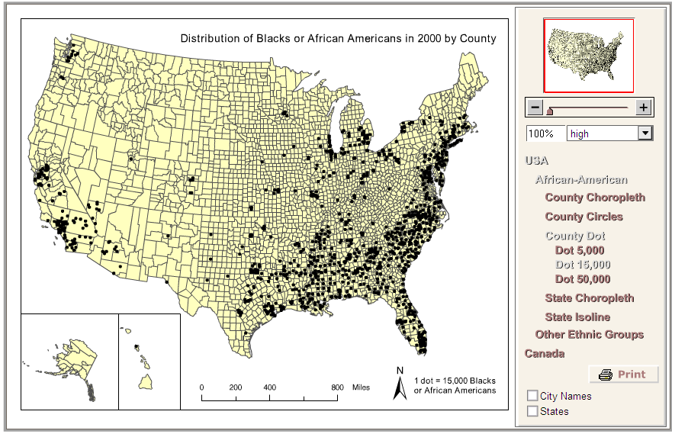

Dot Map- 50,000
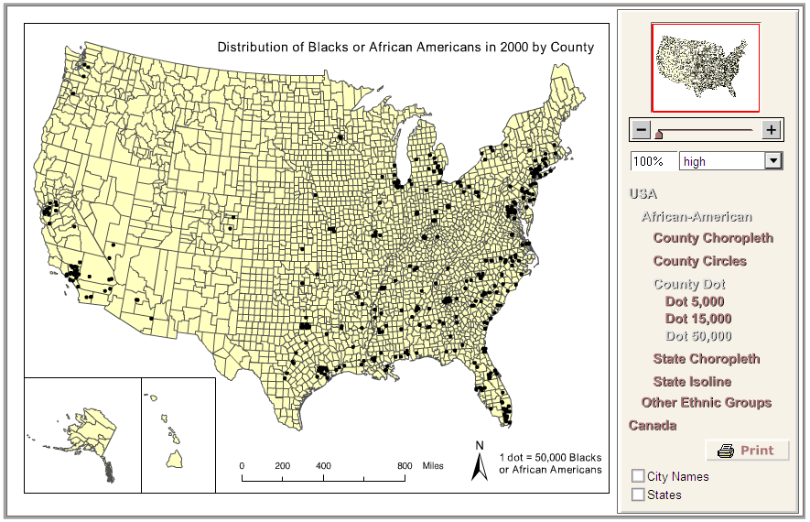

State Choropleth Map- Light to Dark- Equal Frequency
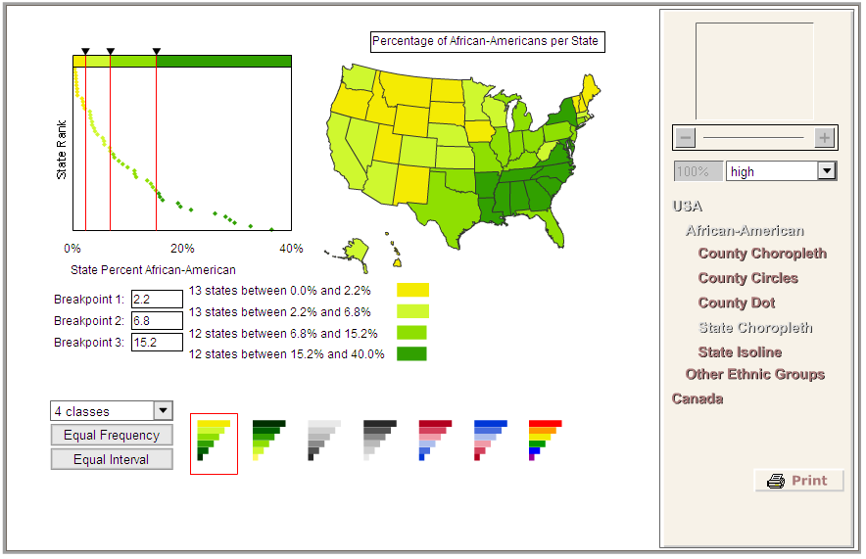

State Choropleth Map- Dark to Light- Equal Frequency
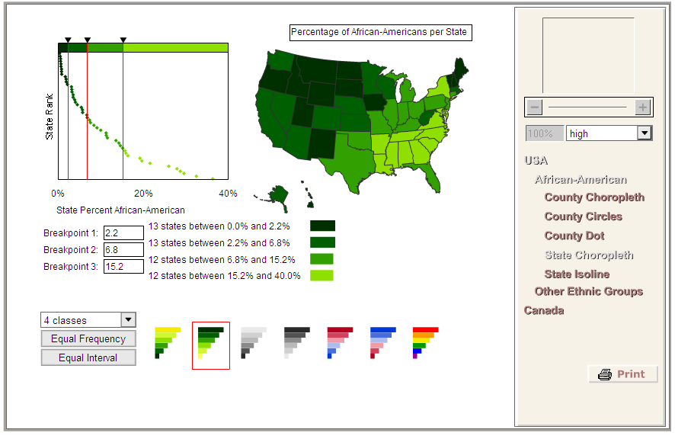

State Choropleth Map- Multicolor- Equal Frequency
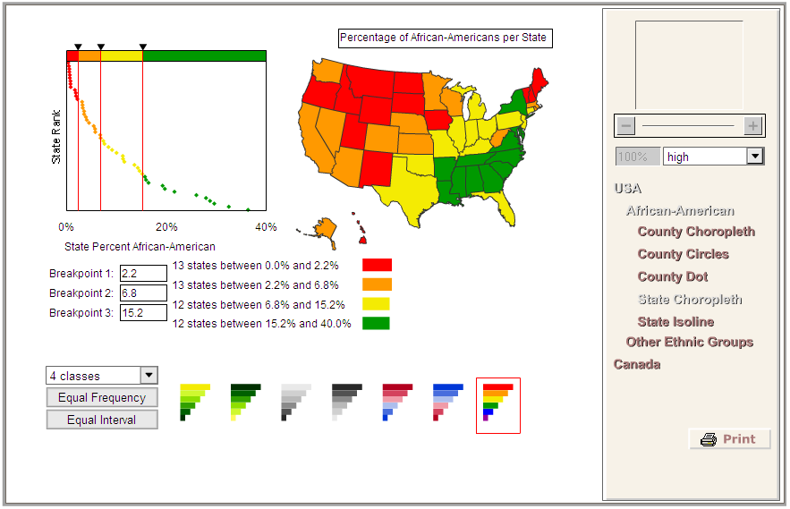

State Choropleth- Light to Dark – Equal Interval
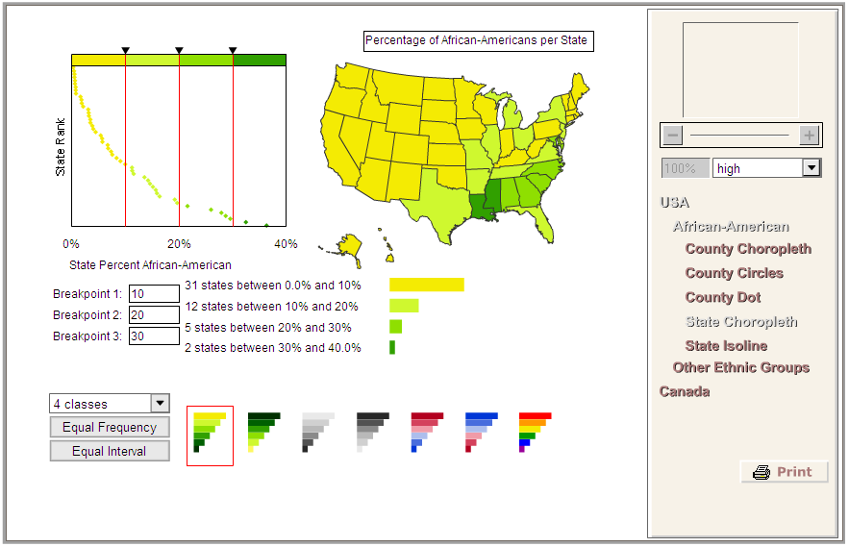

State Choropleth- Dark to Light – Equal Interval
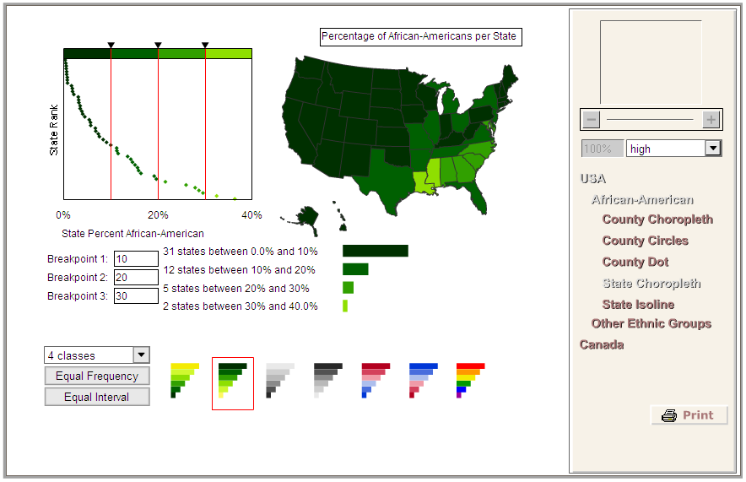

State Choropleth- Multicolor – Equal Interval
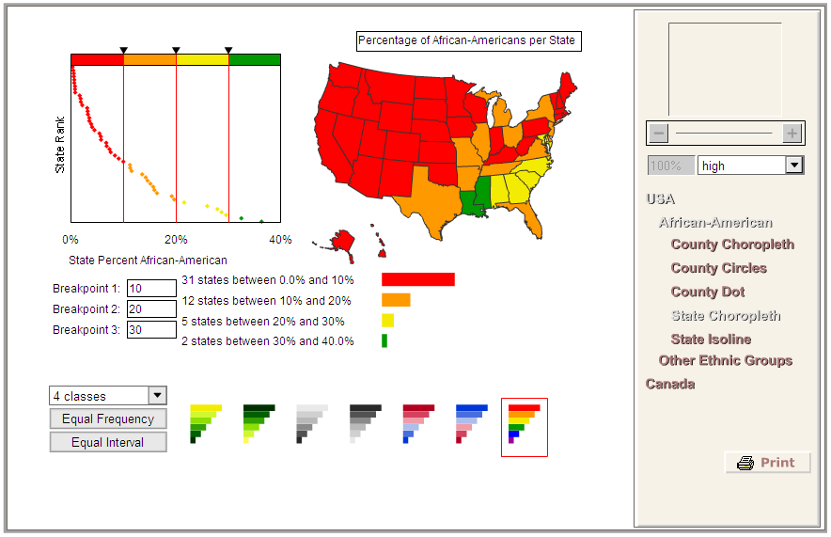

State Choropleth- Dark to Light – Equal Frequency- 5 classes
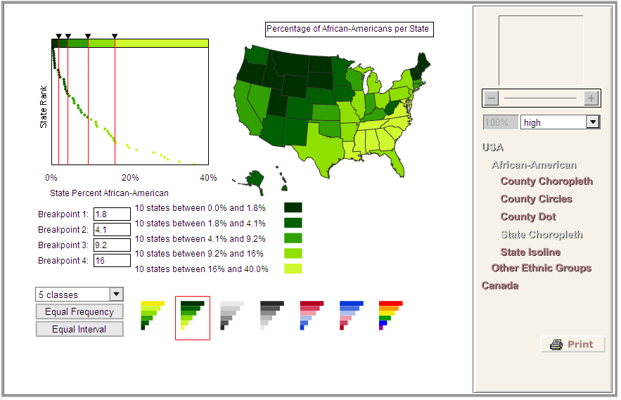

State Choropleth- Dark to Light – Equal Interval- 5 classes
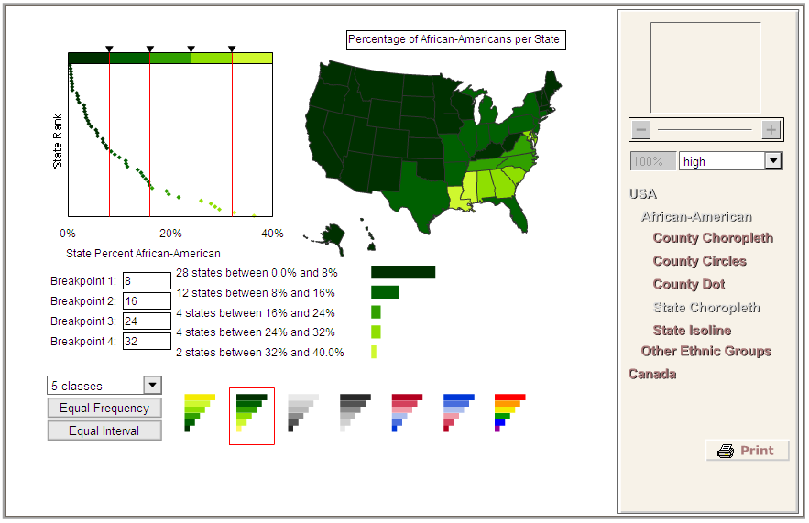

State Choropleth- Dark to Light – Equal Frequency- 6 classes
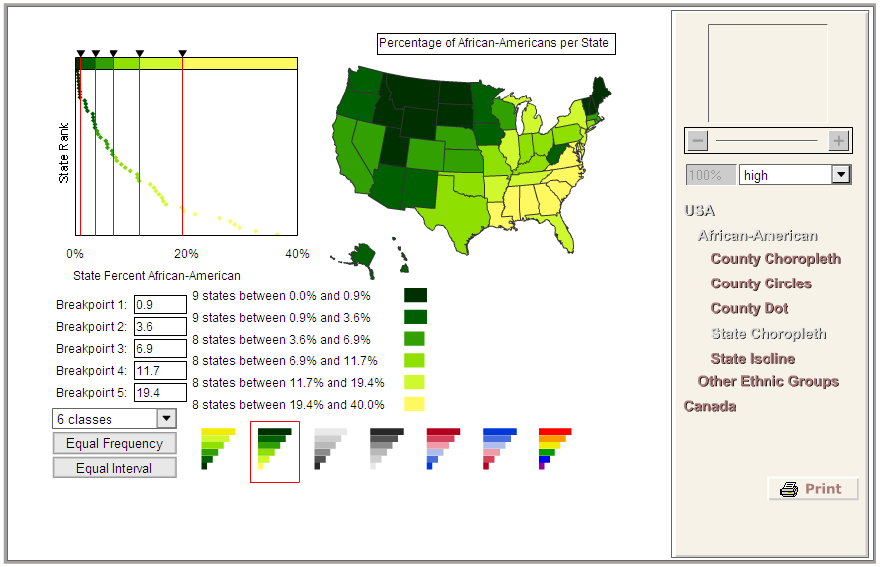

State Choropleth- Dark to Light – Equal Interval- 6 classes
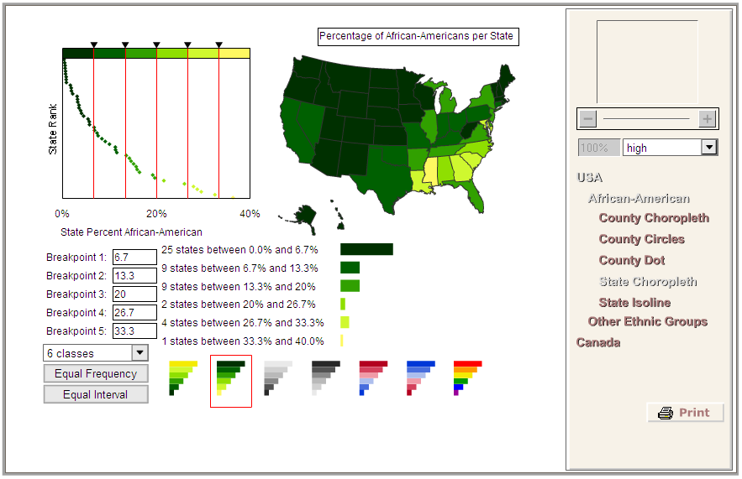

State Isoline
